OVEREATERS ANONYMOUS – Dutch Intergroup-
ANNUAL CLOSED RETREAT
Bacharach, Germany
16 - 18 September 2022
“Together we can”
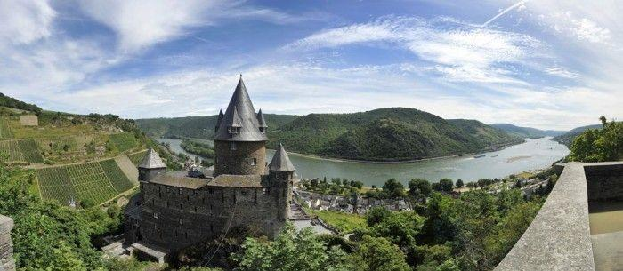

- GENERAL INFORMATION
Held at Burg Stahleck Youth Hostel (Jugendherberge), a beautiful fairy-tale castle above the town of Bacharach on the Rhine River. Retreat activities start Friday evening and last until Sunday lunchtime. All meetings and activities are in English. This is a closed retreat.

- INFORMATION ABOUT THE HOSTEL
- The rooms hold up to 4-8 people.
- Bed linen is provided but you must bring your own towel.
- Food is typical “youth hostel cuisine” and is served buffet style with a vegetarian option. Unfortunately, the hostel is unable to accommodate food choices beyond that.

- PRICES
Retreat registration fee
- Registration fee for retreat activities: € 10,50. Everyone must pay this in addition to any food and accommodation costs below.

Accommodation and food
- Shared room & full board at the castle for the whole weekend: € 76,00 incl. Sunday lunch
Shared room & full board at the castle for the whole weekend: € 69,80 excl. Sunday lunch
- Separate costs for shorter visits:
One night: € 38,00
Breakfast: € 7,00
Lunch: € 7,40
Dinner: € 9,50

- REGISTRATION PROCEDURE
- STARTING DATE REGISTRATION IS 1st MAY 2022
- Registration fees are non-refundable, but you can ask someone else to take your place
- Registration is complete when we have received your form and registration payment
- DEADLINE FOR ROOM BOOKINGS IS 1st​ AUGUST 2022: You need to have sent in your registration form and paid for your room by then.

- REGISTRATION INFORMATION
Please fill out the form below if you want to register for the Bacharach Retreat. Send this form (or all the requested information) by email to: bacharachretreat@gmail.com
- After you have registered by email, you will receive a confirmation email of your registration
- This e-mail confirmation will contain details for how to make the payment.
- Please make all payments by bank transfer to the account (account number will be provided once you have registered), quoting the payment reference given in the registration confirmation e-mail.
- Money must be in the account by 1st August 2022
- FURTHER ACCOMMODATION OPTIONS
You can’t make reservations for single or double rooms, so if you want to stay in a double room, we recommend booking a room in a hotel in town. If you do not want to stay at the hostel (or if you wish to register later), there are several other hotels in the town of Bacharach (the castle is a 15-30 minute walk up the hill from the town). You will still need to pay the € 10,50 registration fee.

Information packs (directions, program, etc.) will be sent out to registered participants approximately 6 weeks before the retreat (mid-August).

Any additional questions? Please contact: bacharachretreat@gmail.com
Please tell people at your meeting about this retreat and forward this information to your fellows who might be interested.

REGISTRATION FORM

Name:
☐ Male ☐ Female ☐ Other
Address:
Country:
Telephone:
Email:
Please indicate which option you would like below
☐ Weekend* (2 nights SHARED room in hostel & meals) |  | € 76,00 + € 10,50 reg fee | € 86,50
☐ Weekend* (2 nights SHARED room in hostel & meals) Excl. Sunday lunch |  | € 69,80 + € 10,50 reg fee | € 80,30
☐ Only retreat activities without accommodation/food |  |  | € 10,50
* PLEASE NOTE every attendee must pay the registration fee € 10,50
☐ Yes, I am willing to do service, please let me know the available positions

Please send this information by email to: bacharachretreat@gmail.com
(The Treasurer of the retreat will then send you a form with the account details for you to pay for the retreat)

The personal information you have completed in this document will be saved in accordance with our Data Protection Statement and the GDPR. A copy of our privacy statement is available on request. If you wish your data to be removed, please email the request to bacharahretreat@gmail.com

